Steps : -

1. Your all files should be in one folder, whether it is of .xlsx, .xlsm, .csv
2. You should have given table names to all files … you can check it from table design tab when you will click over the table
3. You will face error if .. you have given tables names only… but not given same name to excel file which you have given to your table name
4. Now go to get data tab .. select “ Get data from folders”

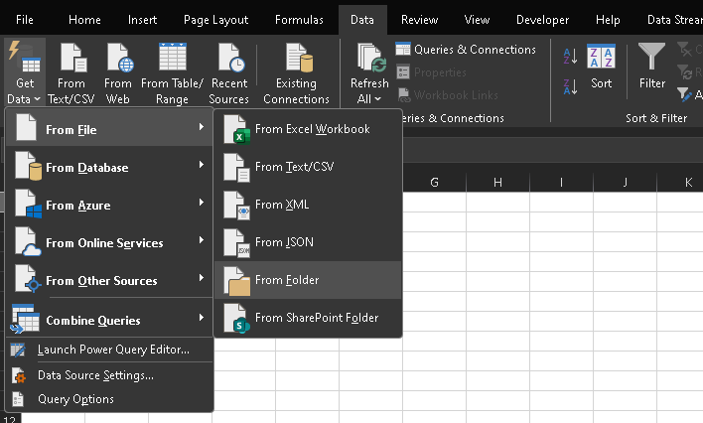

When you have opened the folder now the scene will be something like … show below

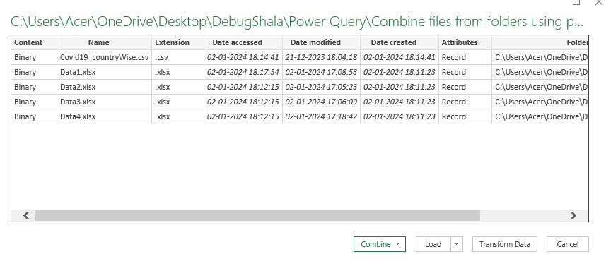

1. ) now if you want to use only .xlsx extension file … select transform data
2. ) 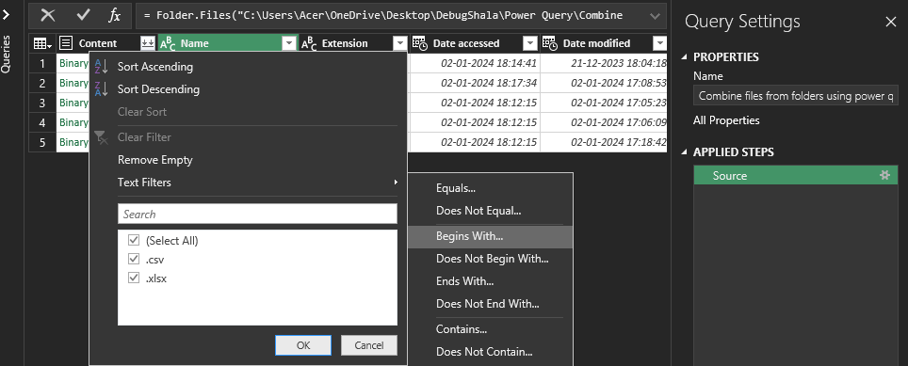
3. ) Choose begins with .xlsl extensions
4. ) if you press merge icons shown on content column , your columns will be merged but with errors because your table name and excel file name are not same

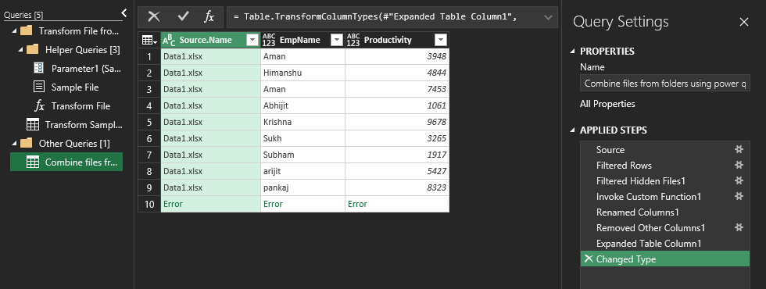

1. ) see in 10 row .. our data is merged but there is error…because power query editor will face issue in

Merging the tables in same sequence

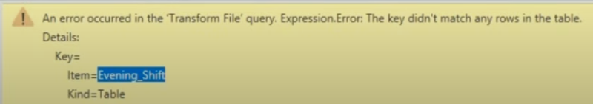

1. ) so to remove these errors we will deleted the performed steps till filtered hidden files 1
2. ) now we will remove another column by right clicking over name column, because we only need content and name

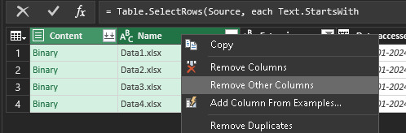

12) Now we will add other custom column by writing excel formula , to see tables under content

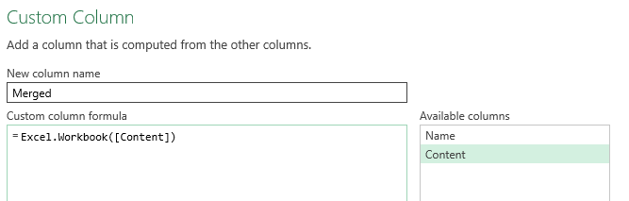

Now we will delete binary ..after we get merged column

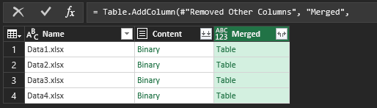

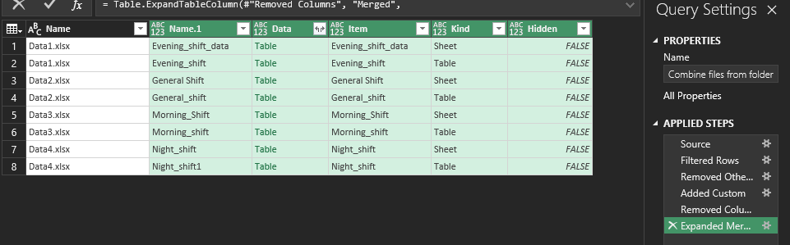

Now we weill only select table … to select only table .. go to kind column

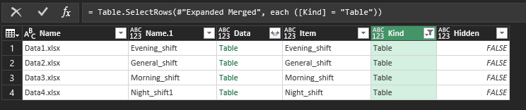

Again we will only choose name, data and will remove another columns

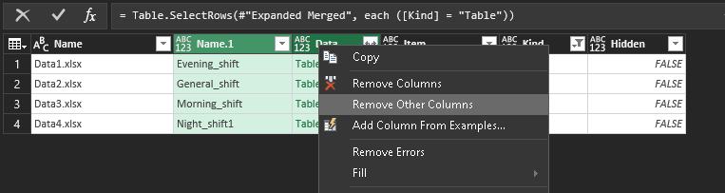

Now it will look like this

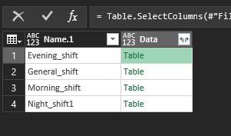

And now click on merge ..shown on data column to merge the data and perform some transformations like removing _sift , check data types and load to excel , your data will be merged to one another

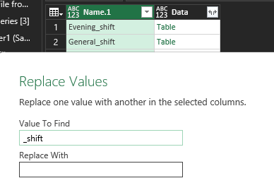

Now when you merge data and performed transformations . then your data will look like this

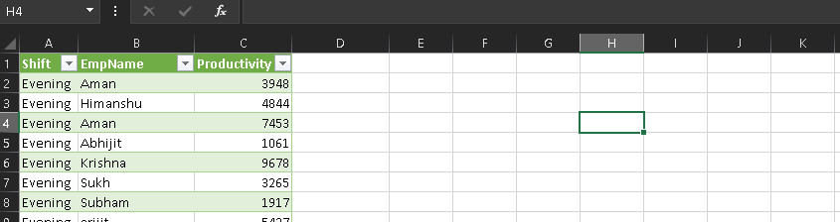

The Beauty of this is that ..

If you copied another .xlsx sheet and pasted into that folder from where we merged the data … all the data will get updated and when you referesh the data .. your rows will get increased from pasted sheet into your folder

It will also update all the rows if you created sub folders inside the folders from where we merged the data

<https://www.youtube.com/watch?v=RZ4EQRg2_CY&list=PLmHi7ol7EPSCqpkQ3DdZuBpPHoBWh7caz&index=9>

you can check this link for revision purpose